Target ID | Ligand ID | Binding Site (Residues) | Docking Results
4896 | S4286 | 246-266 | 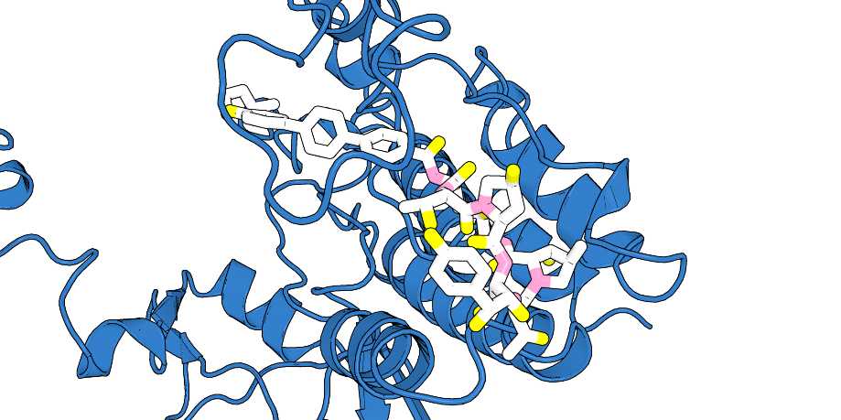
4896 | S1902 | 246-266 | 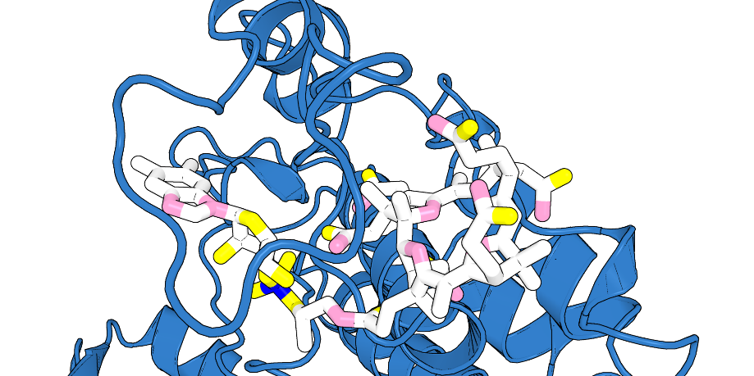
4896 | S3919 | 246-266 | 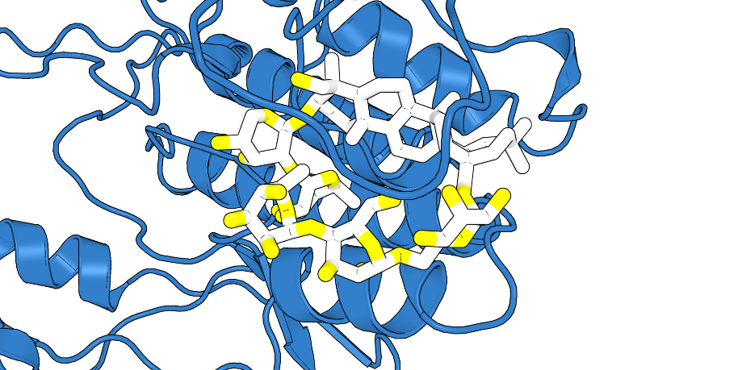
1974 | S1183 | 800-850 | 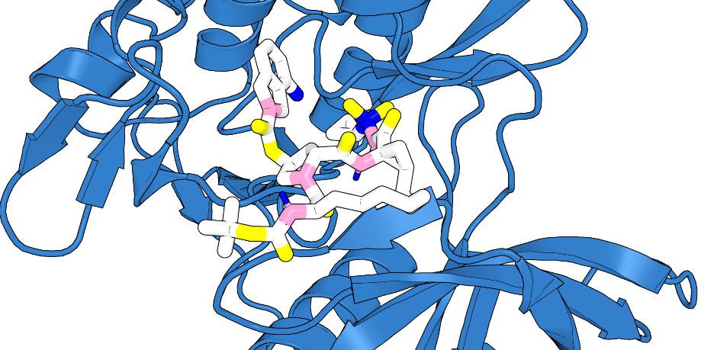
1974 | S1902 | 572-586,  800-850 | 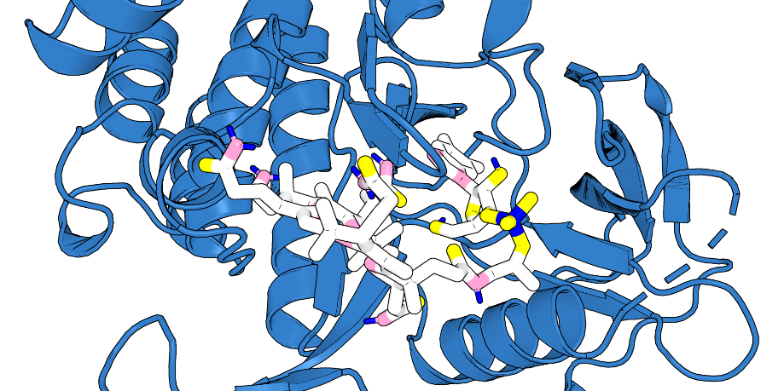
1974 | S2497 | 572-586,  800-850 | 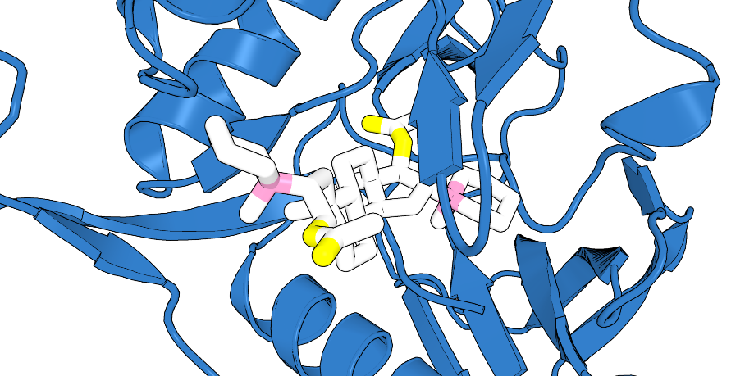
1974 | S4259 | 572-586,  800-850 | 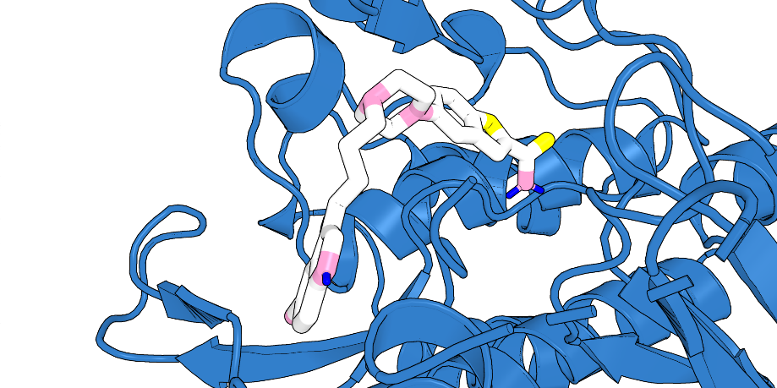
1974 | S4286 | 572-586,  800-850 | 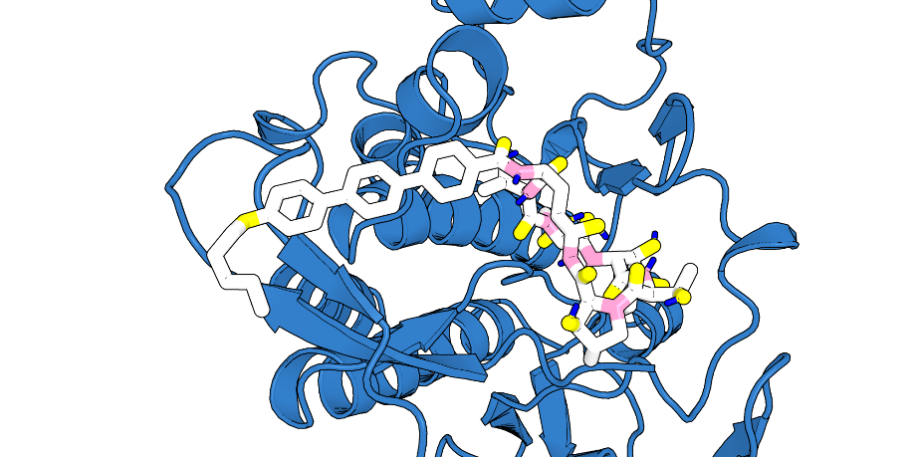
1974 | S2387 | 572-586,  800-850 | 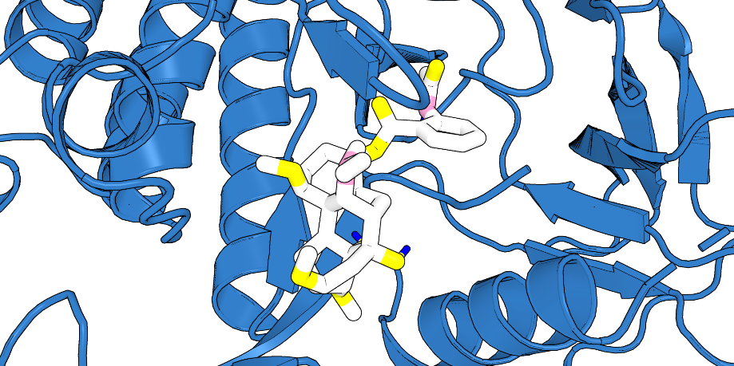
1974 | S4222 | 572-586,  800-850 | 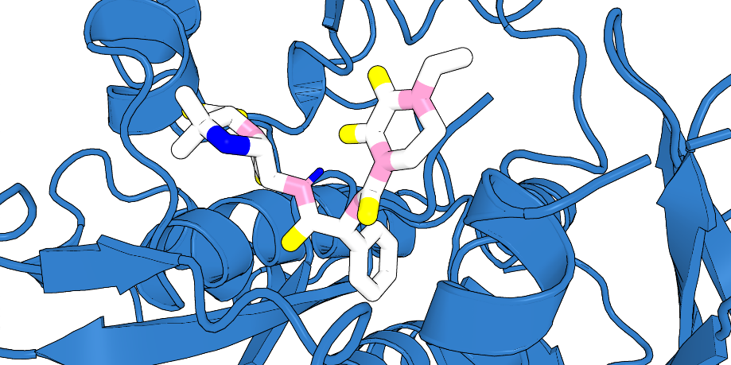
1974 | S1888 | 572-586,  800-850 | 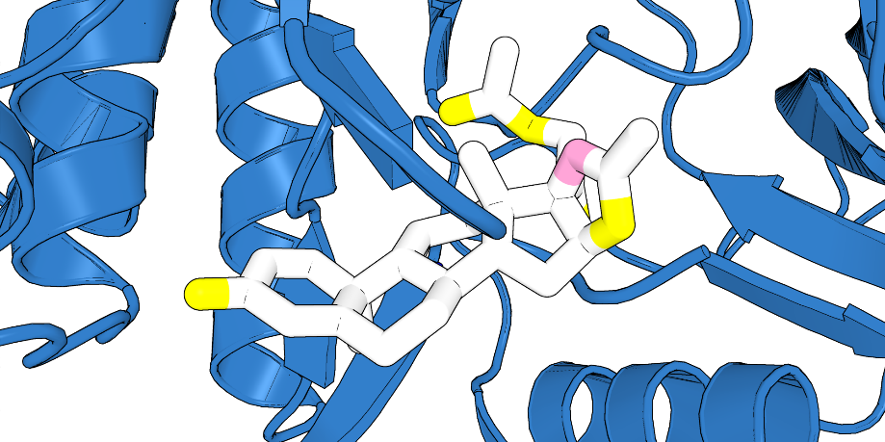
1974 | S2549 | 572-586,  800-850 | 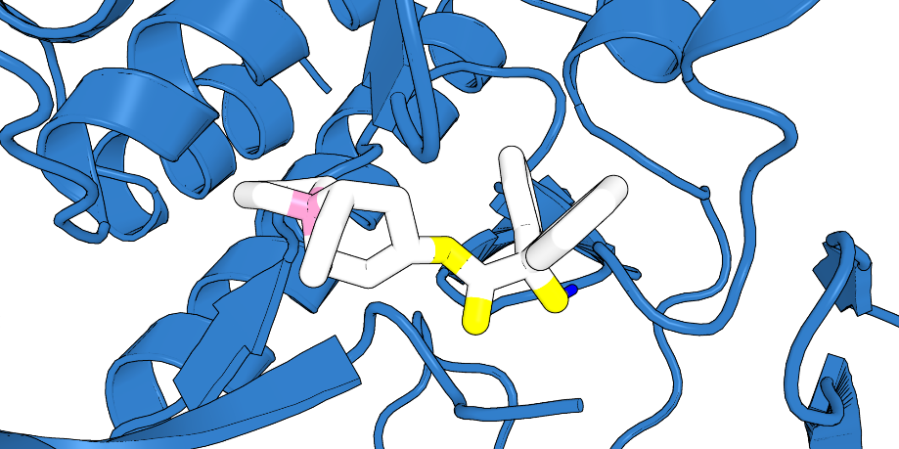
1974 | S3195 | 572-586,  800-850 | 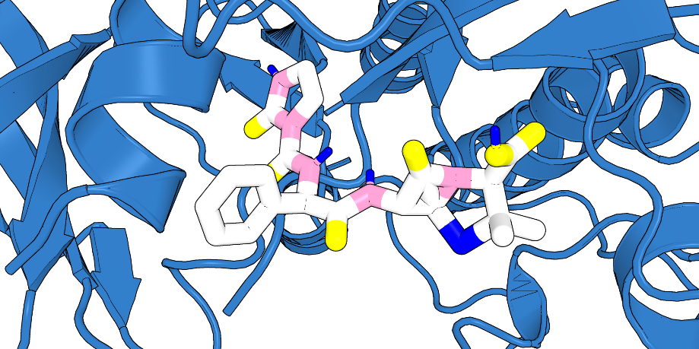
1974 | S4179 | 800-850 | 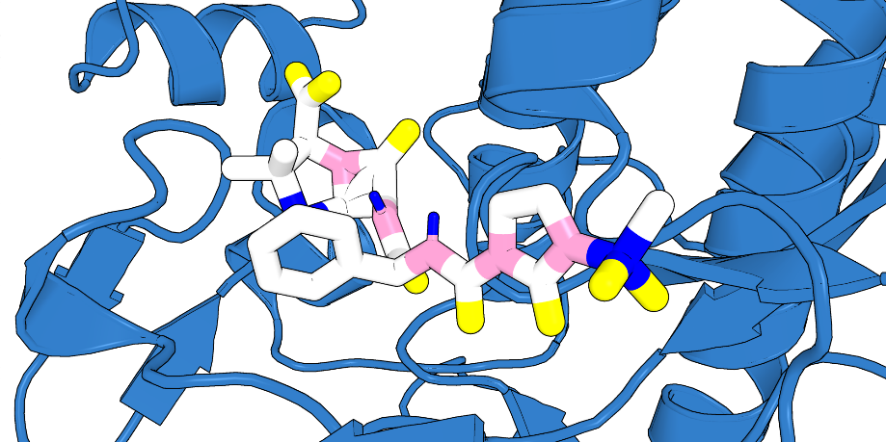
1974 | S2481 | 800-850 | 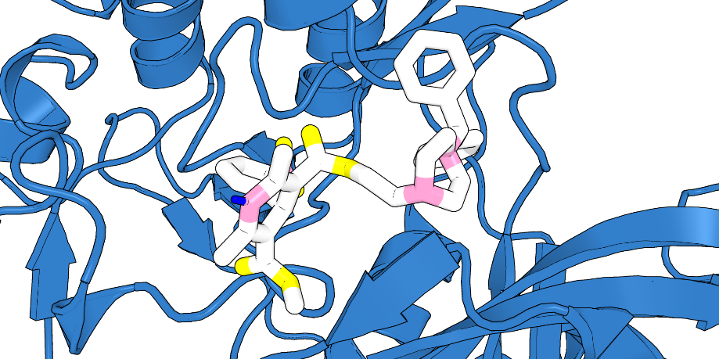
1974 | S3637 | 572-586,  800-850 | 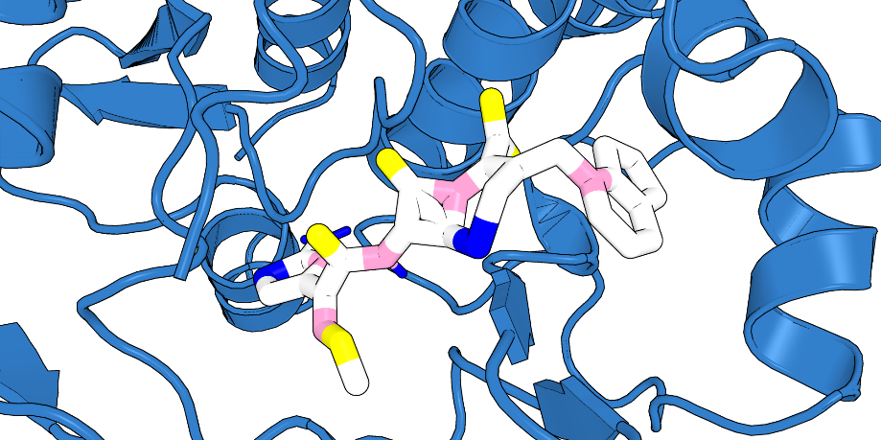
1974 | S1620 | 572-586,  800-850 | 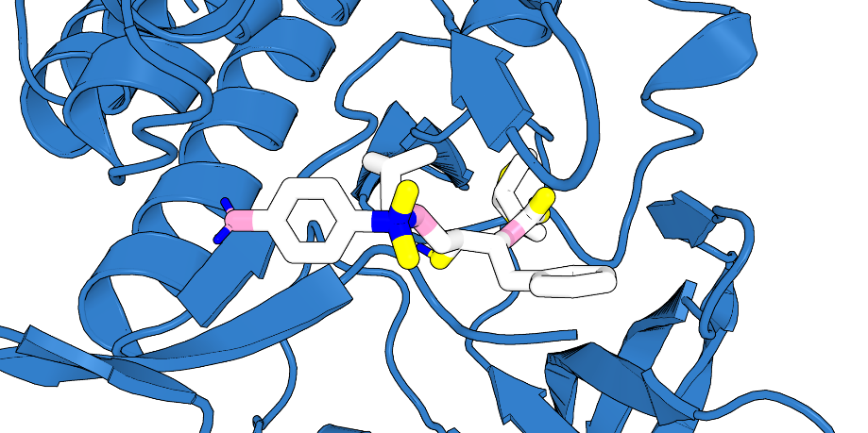
1974 | S2482 | 572-586,  800-850 | 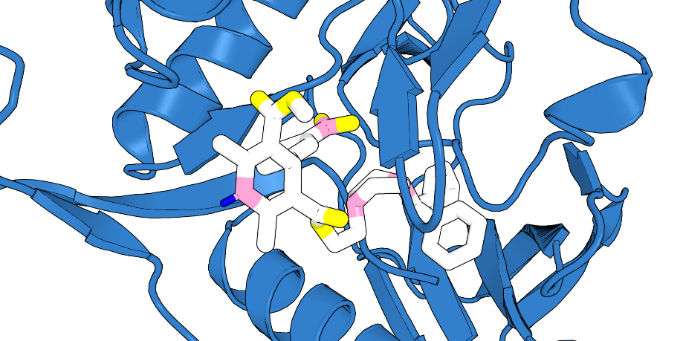
1811 | S4227 | 260-280 | 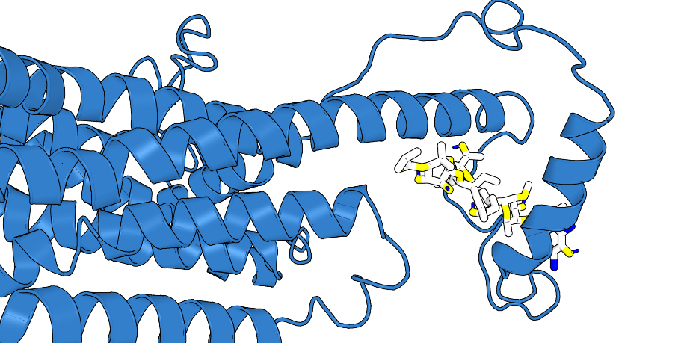
1811 | S1183 | 260-280 | 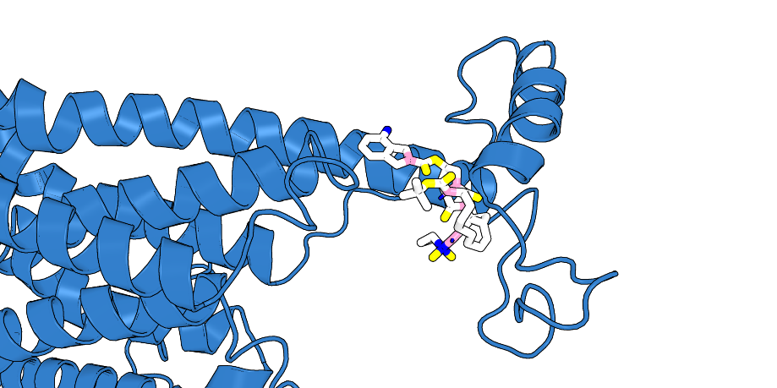
1811 | S1655 | 260-280 | 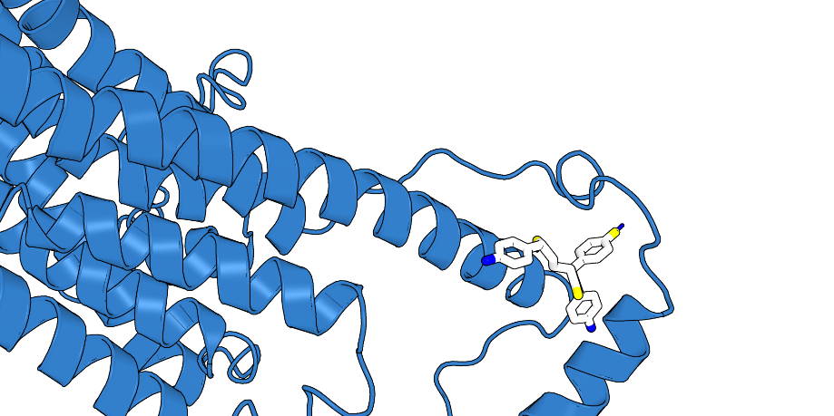
1811 | S1760 | 260-280 | 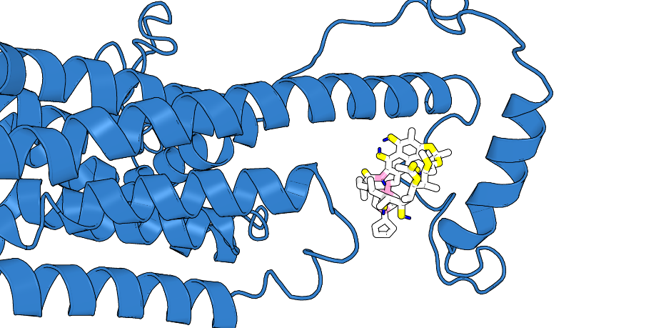
1811 | S4122 | 260-280 | 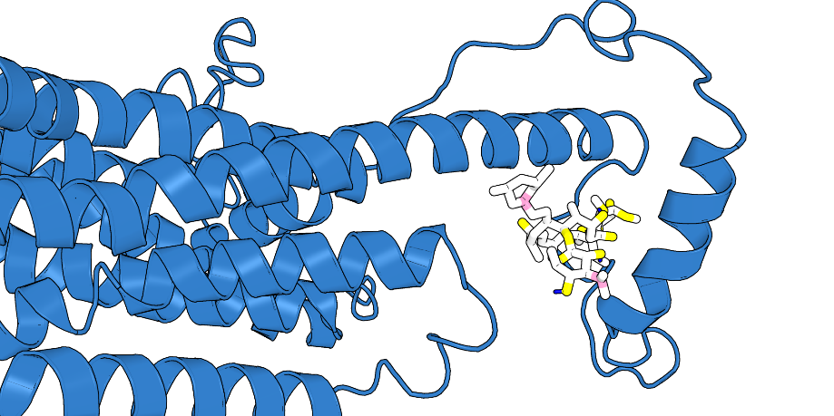
1985 | S3714 | 340-360 | 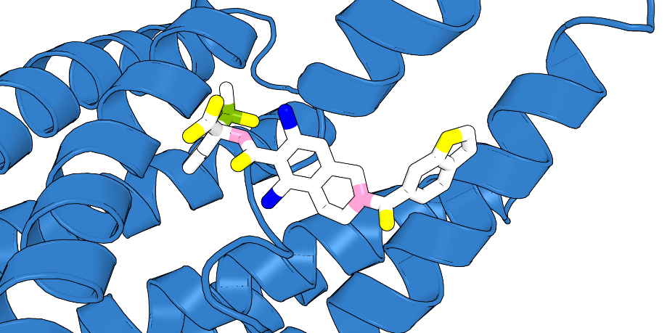
1985 | S2792 | 340-360 | 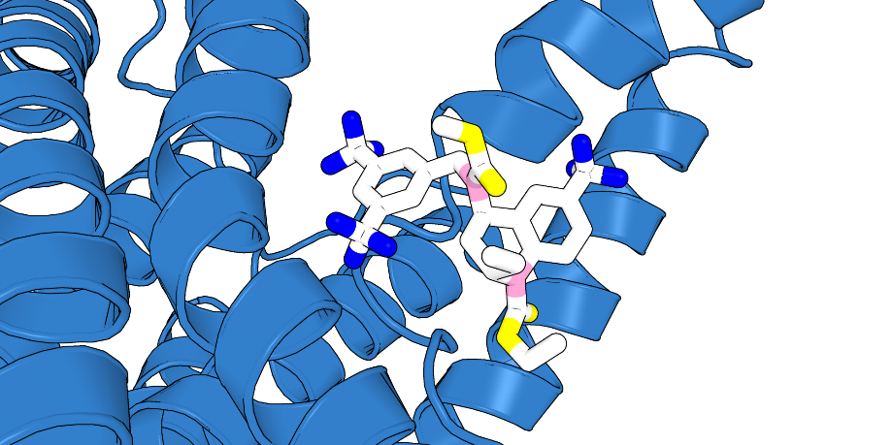
1985 | S2229 | 340-360 | 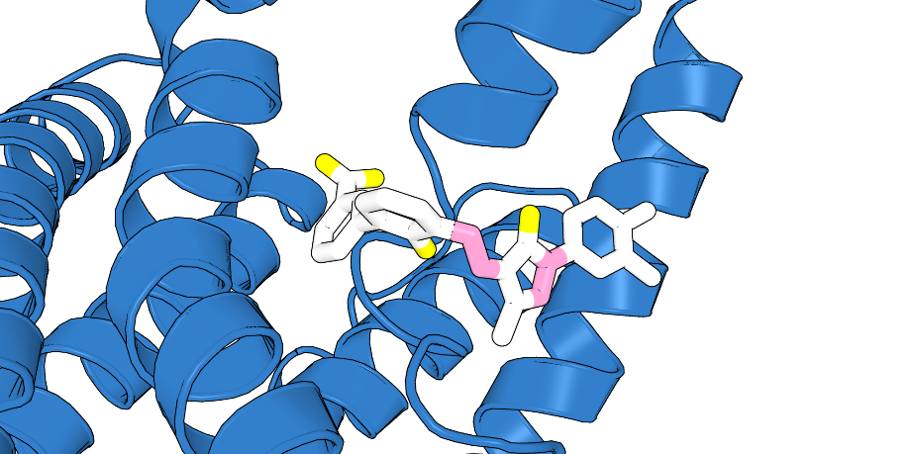
1985 | S1655 | 340-360 | 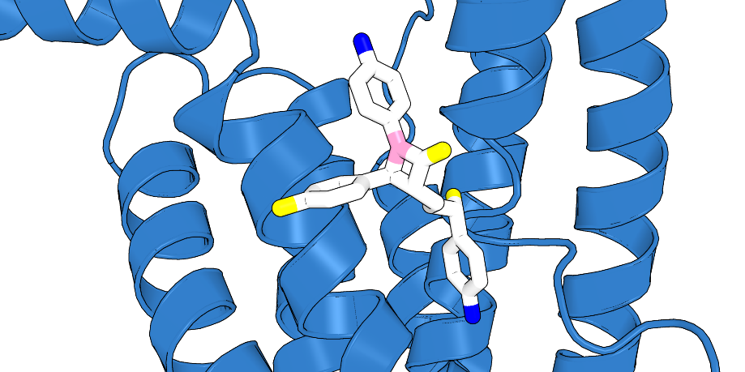
1985 | S2116 | 400-415 | 